Stock Overflow

User Manual

Reference : MU_UserManualTemplate.doc

Version 1.0

Authors:

Rena Chen

Garrett Oldani

Christian Villa

Zhongyang Gao

Edgar Lugo

CSCI 310 -- Group 12

Purpose of the document

The purpose of this document is to provide the user

with simple steps on how to use our web application.

Contents

Purpose of the document 1

Validation 2

1. Icons Used in the Manuel 4

2. Presentation of the Solution 4

2.1 Brief description 4

2.2 Descriptives Icons 4

2.4 Support 5

2.5 Referenced Documentation 5

3. Connecting to the Application 6

3.1 Address 6

3.2 Authentication 6

4. Structuring of the Application 6

4.1 Layout 6

4.2 Menus 7

4.3 Icons / Shortcuts 7

4.4 Functionalities 7

4.4.1 Functionalities Presented/Described 7

4.4.2 Functionalities not Presented/not Described 7

5. Function XXX / Screen XXX 7

5.1 Screenshot 7

5.2 Descriptions of fields, content 8

5.3 Description of actions 8

5.4 Sequence of screens 8

6. Function XXX / Screen XXX 8

6.1 Screenshot 8

6.2 Descriptions of fields, content 8

6.3 Description of actions 8

6.4 Sequence of screens 9

7. Appendices 9

7.1 Appendix 1 9

7.2 Appendix 2 9

# Icons Used in the Manuel

Throughout this document, the pictograms below are used to underline points or important notions

|  |  |
| --- | --- |
| icono2 | Important information |
| Light Bulb On 32 h g | Good to know - Tricks |
| icono3 | **Risk** in front of a parameter setting or of a specific action |
| icono1 | Action to be avoided |
| icono5 | Mandatory action |
| icono4 | Sensitive or difficult procedure. To take into account necessarily |

## Support

Please feel free to contact any of the developers for support.

Rena Chen -- renachen@usc.edu

Garrett Oldani -- oldani@usc.edu

Christian Villa -- christdv@usc.edu

Zhongyang Gao -- zhongyag@usc.edu

Edgar Lugo -- edgarlug@usc.edu

## Referenced Documentation

Here is some documents that can help the user in understanding stocks and how to invest :

How do stocks work ?

<http://www.investopedia.com/articles/basics/03/103103.asp>

How to start investing with $2000

<http://www.nasdaq.com/article/how-to-start-investing-with-2000-cm586520>

# Connecting to the Application

## Address

To access StockOverflow, launch Firefox from the sidebar and enter the following **URL: https://localhost**.

## Authentication

The user must provide username and password for authentication. On this application, the username is the users email. You will then be directed to the login page. Your username is halfond@usc.edu and your password is password.

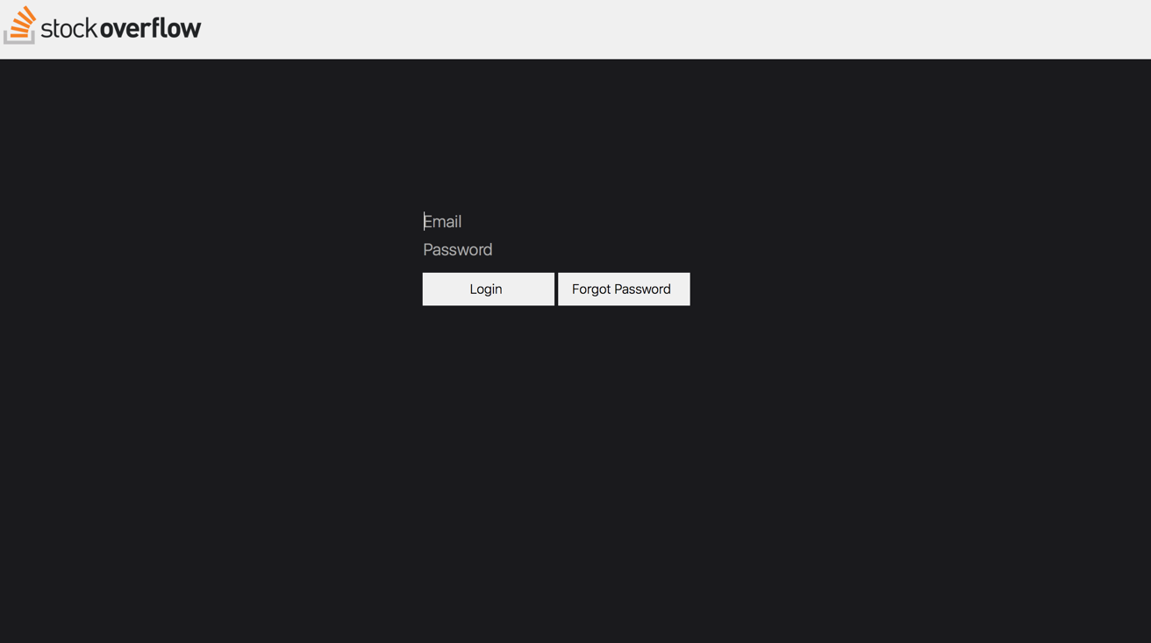

# Structuring of the Application

## Layout

StockOverflow contains three sections, a top bar, left side, and right side. There is a top bar for control, two lists and a box for buying a selling stocks to the left, a graph section and information box to the right of the web page.

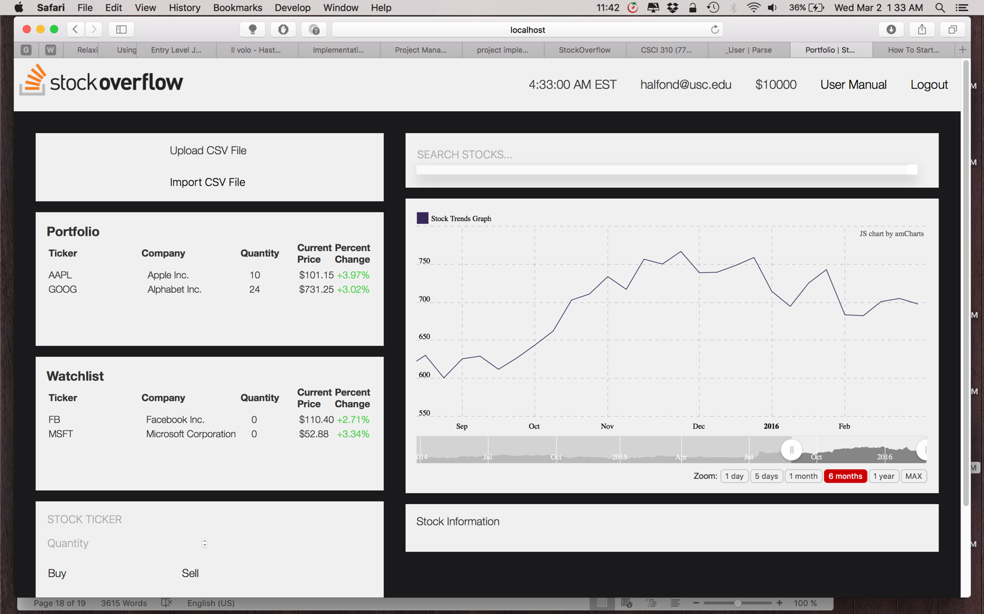

## 3.2 Components

StockOverflow Logo: Simply our logo which refreshes the webpage on click.

Time: Shows current time (EST).

User name: Email provided by the user at authentication.

Current Balance: Provides current amount of money the user can user to purchase stocks.

User Manual: Provides a link to this document.

Logout: Ends the user’s current session.

Upload CSV file: Uploads the provided file by the user.

Import CSV file: Imports the provided file by the user, changing his stocks on the lists.

Owned List: Shows stocks owned by the user with quantities.

Watch List: Shows stocks the user is interested on.

Buy/Sell Stock: With input of symbol and quantity, the user can buy stocks that are already on the watch list, or sell stocks that are already on the owned list.

Search Bar: The user can search by company name or symbol.

Graph: Shows stock prices for 1 day, 5 days, 3 months, 6 months, 1 years, and all time prices.

Information Box: Provides information about the stock (company?)

## Functionalities

### Functionalities Presented/Described

1. Searching Stocks
2. Adding stocks to watch list
3. Showing stock info in graph
4. Buying and Selling Stocks
5. Importing a CSV file

# Function XXX / Screen XXX

<Description of the functionality >

## Screenshot

<Not absolutely necessary but often very useful, with arrowed explanations, and boxing or circling of different fields for user input or presentation>

## Descriptions of fields, content

<Show the fields, particularly the mandatory fields, and/or the input masks which are checked

Show the colour codes if there are any.

Show the lists and explain their content

… >

## Description of actions

<Explain the actions possible for the given screen, and the consequences, without reproducing the functional specifications.

Nevertheless it may prove useful, if not necessary, to reiterate a business rule or management rule.>

## Sequence of screens

<If necessary show the sequence of screens.>

# Function XXX / Screen XXX

<Description of the functionality >

## Screenshot

<Not absolutely necessary but often very useful, with arrowed explanations, and boxing or circling of different fields for user input or presentation>

## Descriptions of fields, content

<Show the fields, particularly the mandatory fields, and/or the input masks which are checked

Show the colour codes if there are any.

Show the lists and explain their content

… >

## Description of actions

<Explain the actions possible for the given screen, and the consequences, without reproducing the functional specifications.

Nevertheless it may prove useful, if not necessary, to reiterate a business rule or management rule.>

## Sequence of screens

<If necessary show the sequence of screens.>

# Appendices

## Appendix 1

<Give here any additional information that could make the functional specifications easier to understand.>

## Appendix 2

End of document